Diary 8:

13/12/2020

# Warzone board game

# Introduction:

In this brief we were tasked to create a physical game out of a digital idea, adapting the mechanics and premises to suit a physical version that largely resembled the original game.

# Premise:

The premise behind the choice of game was to create a battle royal experience on a physical level through the use of a board game with trading card elements. It meant the player could connect with the game more without relying on their skill to get them to a higher standing within the game, meaning the game became more inclusive.

# Mechanics:

[A]

To aid in the choice of character within the digital game, the physical game provides a character sheet that allows the player to choose their own character which provides starting boosts for the player.

This game also implements a trading card style element in which the player can build their hand, in order to boost their characters stats during combat.

These allow the game to keep its core premise in being the last one alive within a battle royale whilst allowing the player to feel more connected to their character and the story they send them on.

# Gameplay:

The beginning of the game, the player must choose a character card that they wish to continue the game with, selecting the character card and character piece to place on the map.

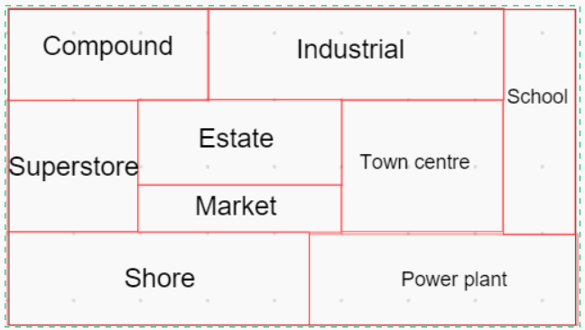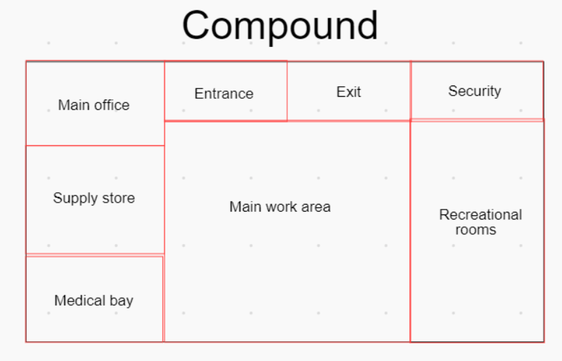

[A]

Figure 2- map

This shows the areas of the map available to the player [A] and how a specific area would look like to the player [B]

[B]

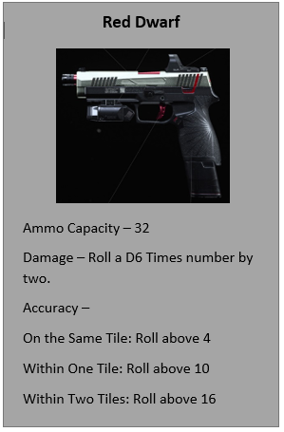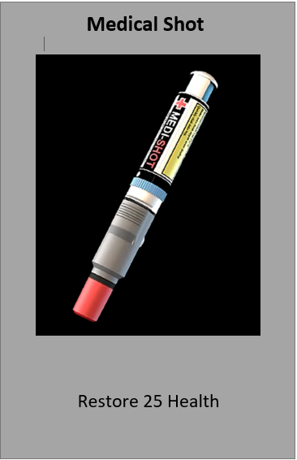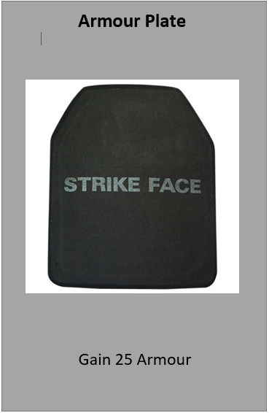Then to begin the game, players place their character in a random area of the map to decide where they “drop” then must throw a 6D die in order to move around the map spaces to get to other players and loot.

[B]

[C]

[A]

Figure 3 - Equipment cards

The scene show equipment card utilised in the game with [A] being a weapon, [B] a health item and [C] and armour card

Players take each other out as well as NPC’s in order to be the last one standing when the storm begins to come in.

# Experience:

Taking everything that happened into consideration, the problems that were encountered were challenging and time consuming, due to the issues with bringing everything from digital to physical.

However, the teamwork involved allowed them to be overcome with ease, each taking a singular element and working out the individual problems before bringing it back to the team to solve the problem as a whole.

# Reflection:

The production of the idea was smooth, transitioning easily into the production with no complications, showing that good teamwork can be beneficial to the overall goal.

However, there could have been a little more communication with the team members, as it did hinder the rule creation a little bit.